Curriculum vitae
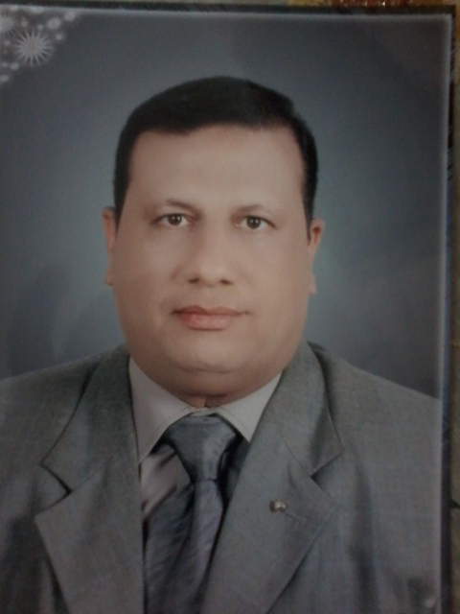
Name: Refaat fathy Abd Elal Nusier
Date of birth 1/5/1961
Nationality: Egyptian
Religion: Moslem
Passport No: 170522
Social state: Married and has 1 daughter
Address: Egypt – Assuit – 33 Taxsim Elawkaph street
Tel Home: 002-0882322659
Mobile: 01001349189

Education
- M.B.B.C.H faculty of Medicine Assuit University September 1985 by very good grade.
- Master degree of internal Medicine Assuit University in 1990 grade is very good.
- Doctor degree of Internal Medicine (MD) Assuit University 30/5/2004
- Attendance of an advanced level of English language program on 1990
- Postgraduate courses and experience:
- Training doctor in Assuit University Hospital from 1/3/1986 to 28/2/1987
- Resident in internal medicine department - Assuit University Hospital 1/3/1987 to 1/3/1991
Worked in Saudi Arabia as internal medicine specialist in International Baha polyclinic 1992-1995 and clinical manager.
* Demonstrator in internal Medicine department Assuit University from 1995- 1996
* Assistant lecturer in internal medicine department Assuit University Hospital from 1/6/1996 to 25/6/2004
* Lecture of internal medicine - Assuit University hospital from 26/6/2004
* Assistant Professor of internal medicine since 2004.

University Teaching:
- Sharing in teaching and clinical training of internal medicine courses to 4th 5th and 6th year undergraduate medicine students in Assuit University Hospital
- Sharing in teaching of academic courses of internal medicine to 1st year nursing students.
- Sharing in teaching of academic courses of internal medicine to many of master degree of different departments in collage.
- sharing in exam of many master degree of different departments in collage.
- sharing in evaluation of many master degree of different departments in collage.
- Sharing in management of patient of Assuit university and out patient clinics.
- Sharing in management of Assuit university staff members
Prevision:
Participating in supervision of many doctor degree. Thesis and many Master degrees.
Memberships in many activates.
Member of Assuit university staff members social club

